**FIRST READ TUTORIAL 2 TO MAKE FIRST PERSON CAMERA**

**Step 1)**

**Create a rifle with unity cubes and parent it to the camera.**

Make a 3-block rifle with the cube 3D object cube.

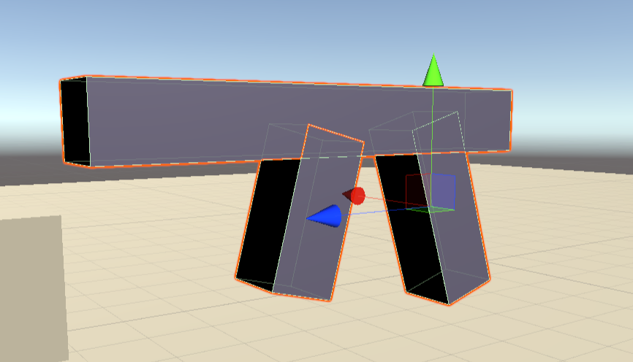

Then in the hierarchy right click the cube and add an empty object, then you will need to put all of them cubes inside the GameObject, and rename it Rifle.

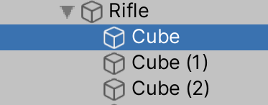

Then just move the rifle into the main camera in the hierarchy.

Next using the GameMode screen and your scene screen line up the gun on the right side until its where you want it, to test how it will look play the game and you will be able to have the gun stick to the movement of the camera.

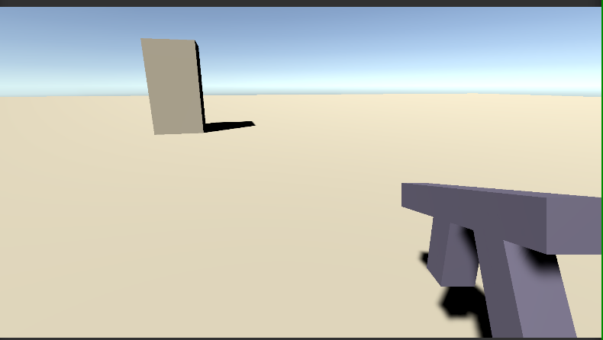

**Step 2)**

**Next add a material to the rifle and script to scene.**

To add a material just right click into the assets and go down to material and just rename RifleMat.

Then just add the colour you want in the inspector, I went with a dark grey colour, and then just drag and drop the material onto the gun.

Next you need to add in another empty object, by selecting the rifle In hierarchy and rename it spawnPoint. Then just move it along the barrel of the gun to be at the front of the rifle where the bullets will come out

Now you need to add in the script on the rifle to do so, select the rifle and go to the inspector and add component.

Type in script and select then rename to RifleScript and open it up.

**Step 3)**

**Write these lines of code to make it shoot**

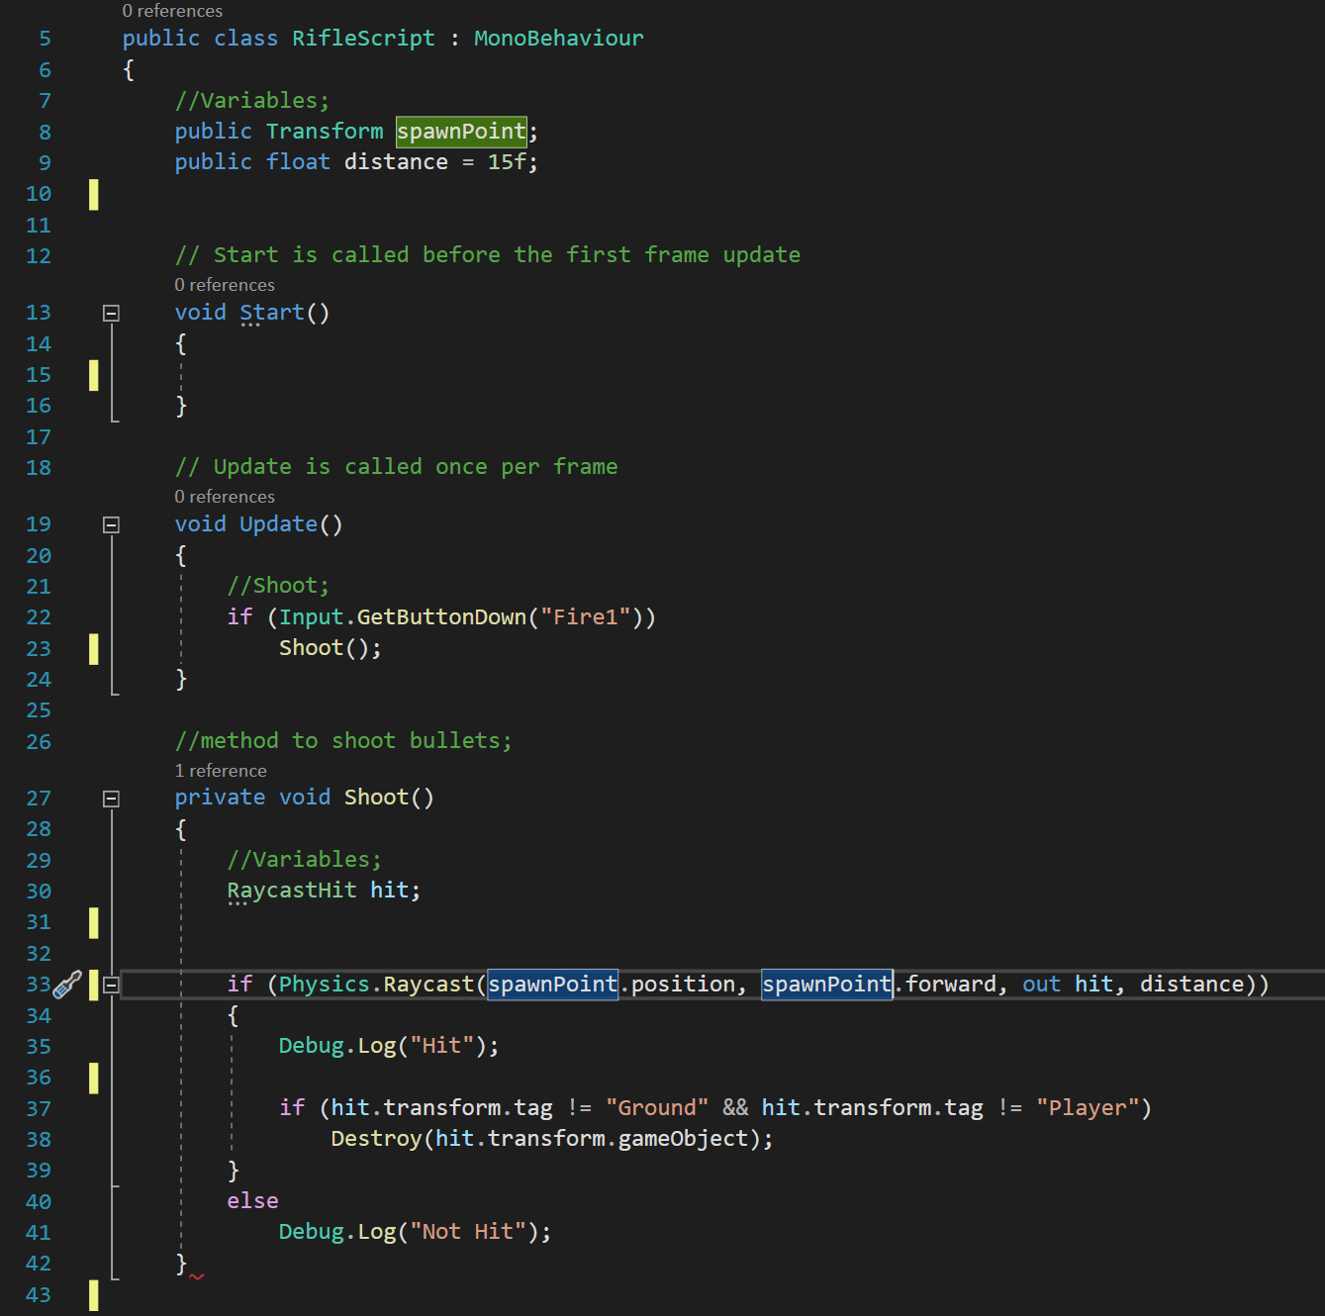

**Step 4)**

**Test The gun and import the asset package, also download a sound for your gun, by using** <https://freesound.org/>

Then to start you need to put the spawnPoint Object into the rifle script in the inspector.

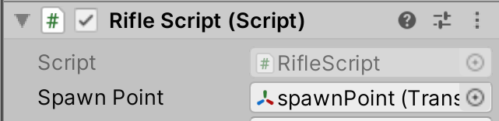

Now test out the gun on the cubes in the scene before it should allow you to destroy them when you click to shoot while looking at them.

Next create a new Empty GameObject into the scene, and call ShootSound in which you will then add a new component called audio sound for the downloaded audio you have made.

Just like the SpawnPoint you now just need to drag the audio clip you downloaded into that component and untick play on awake.

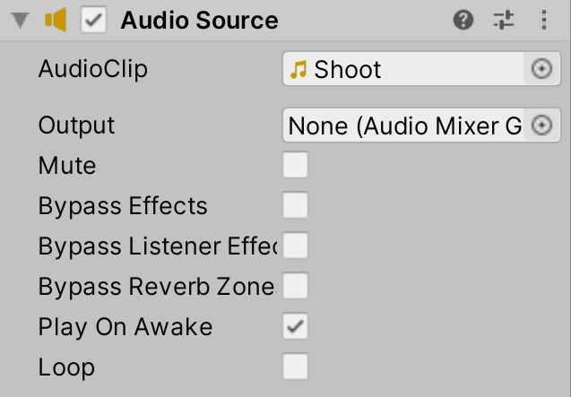

Then go into the asset store and search unity particles in the search bar and download a pack called Unity particle pack.

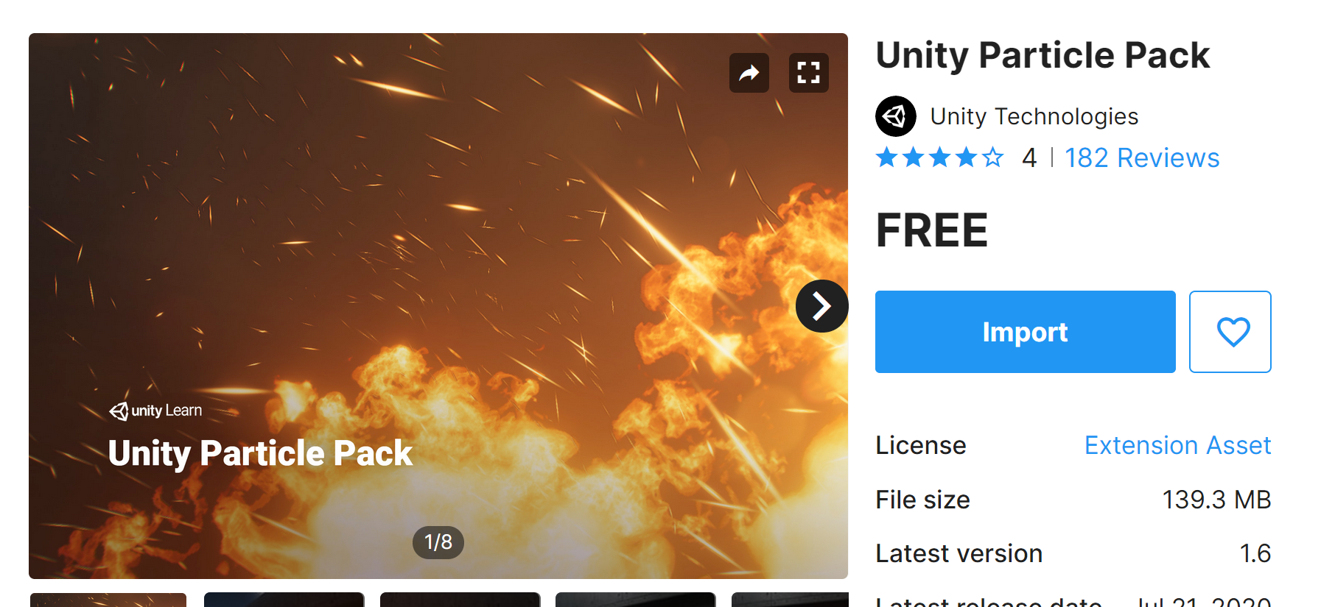

Download and import the pack.

Then go to Assets - EffectExamples – Weapon Effects – Prefabs

And select Muzzleflash and drop into scene.

Then in the inspector untick looping, then change **Stop Action** to **Destroy** and finally change the name to the muzzle flash to **MuzzleFlash01_2.** Then drag the muzzleflash from hierarchy back into the same prefab file next to original MuzzleFlash01.

The next thing to do is very similar, in which you will need to go into Assets – EffectExamples – Fire & Explosions Effects – Prefabs and drag **Dustexplosion** into the scene.

Then follow all these settings for the DustExplosion.

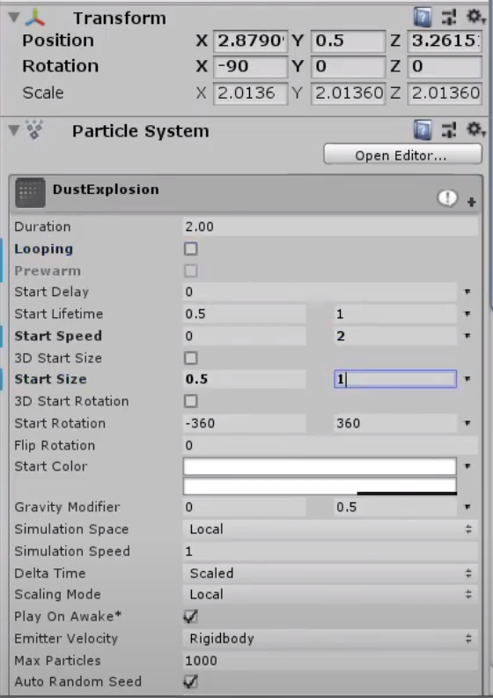

Then next go to Embers in the dust embers prefab and change these settings

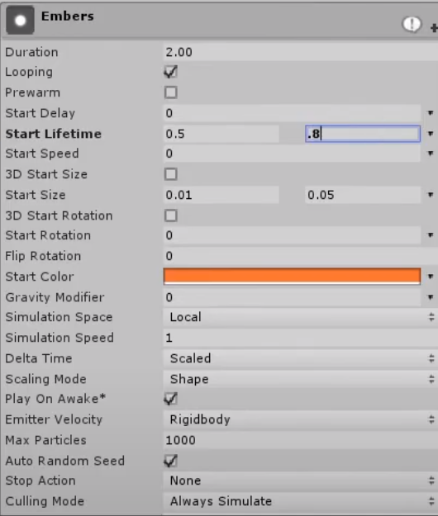

Then next go to SmallExplosion and change these settings

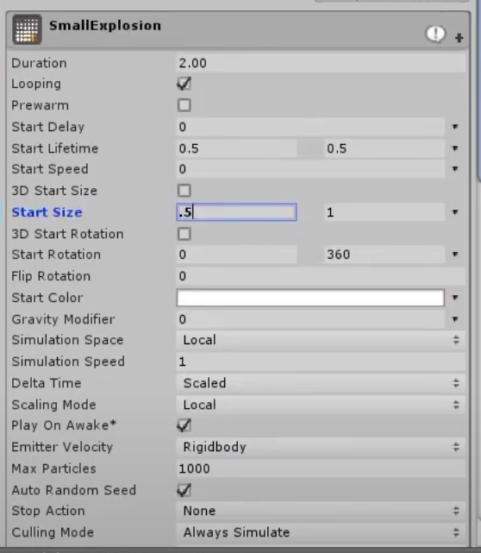

Then go to SandParicle and change these settings

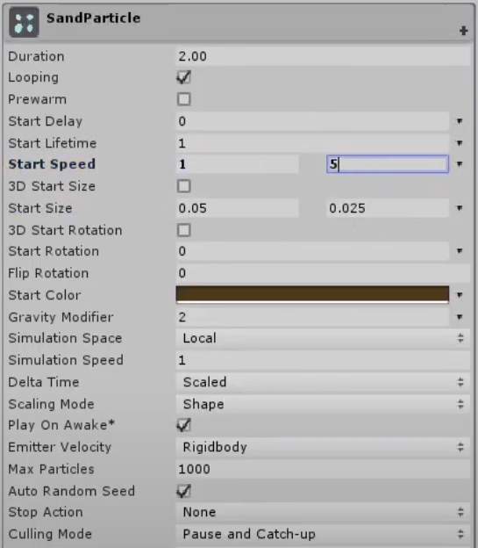

Then lastly in shockwave change the start size to 1

And again, change the name of the dustexplosion to **Dustexplosion_2** and put that back into the prefabs folder.

Now delete the Dust explosion and Muzzle Flash in the scene.

**Step 5)**

**Modify the script to add the effects we want.**

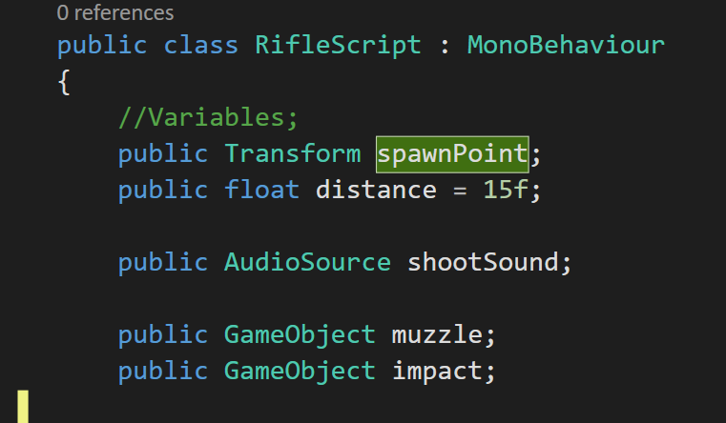

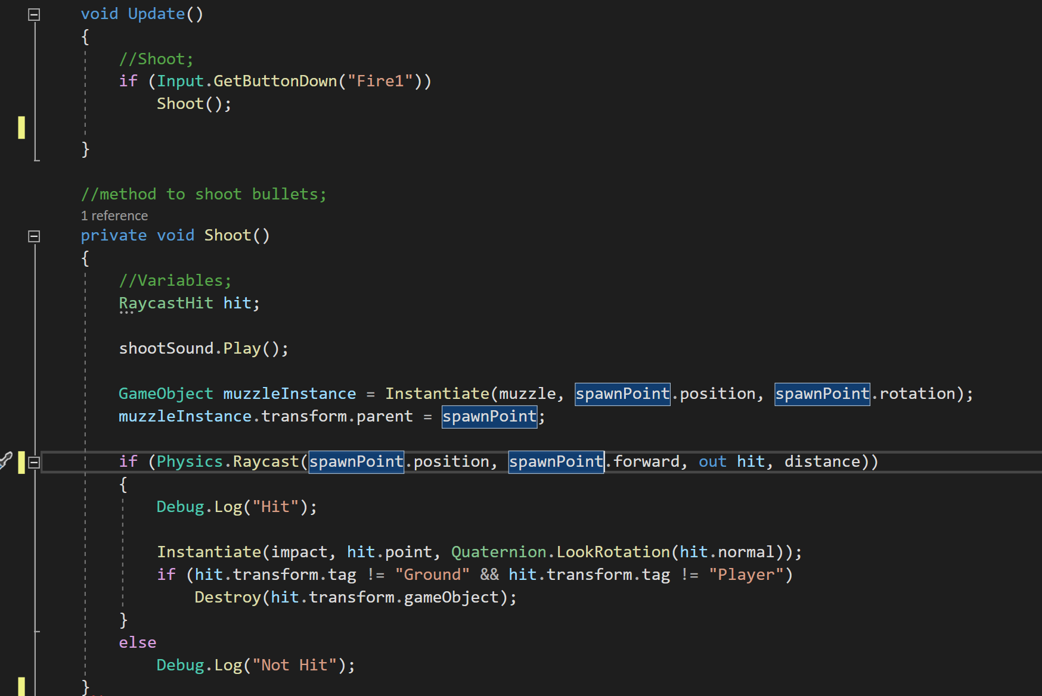

**Step 6)**

**Assign everything and you have a rifle!**

